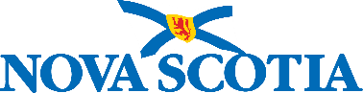

Inclusive Education Policy Lens Tool

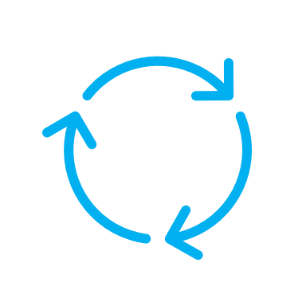 | The Lens Tool is intended to be used throughout the policy development or review process and should help shape engagement with community and government partners.
 | The Inclusive Education Policy should be the touchpoint and referenced throughout the process.
 | The Lens Tool is considered complete when each numbered question can be answered with “yes.”
 | The prompts are starting points for considerations and conversations and are not exhaustive.
If you answer “no” to all the questions, do not worry! Throughout
the process you will work to answer “yes” to each question through engagement, collaboration, and research.
Where you think the answer could be “yes,” but there is still more work to be done, please answer “no” and develop a process or plan
to address any next steps or recommendations.

Inclusive Education Policy Lens Tool

Name of policy or instrument:
Submitted by (name, title, organization):
Policy lead:
Date completed (DD/MM/YYYY):

Questions
- Does this policy support the guiding principles of the Inclusive Education Policy in both practice and in intent?
☐ Yes ☐ No
Comments:
- Has action been taken to include student, parent/guardian, and/or community first voice authentically and consistently throughout the policy development/review process?
☐ Yes ☐ No
- Prompt: What space does your organization have to best accommodate the community being engaged? Has the capacity to participate been considered (language, locale, time of day, accessibility, childcare, etc.)?

- Does the policy reflect the interests and concerns of students who are historically marginalized and racialized (including, but not limited to, African Nova Scotian and Mi’kmaw students)?
☐ Yes ☐ No
- Prompt: How have these communities been engaged? What partner groups could help to facilitate engagement? How do these communities define what success means in relation to the policy?

- Prompt: Does the policy reflect Netukulimk and Mi’kmaw Ways of Being and Knowing? Does it reflect a wholistic approach to well-being?

- Does this policy reflect the interests and concerns of students who come from other groups that have been traditionally under-represented and under-served (including, but not limited to, students with disabilities and those struggling with poverty)?
☐ Yes ☐ No
- Prompt: Have groups such as 2SLGBTQIA+ students; students who are newcomers; children and youth in care; students experiencing mental health related needs; students receiving Justice services; and Francophone or Gaelic students been considered?

- Prompt: Does the policy unintentionally reinforce gender norms that have historically been harmful?

- Prompt: Which groups of students are most impacted by this policy? Have they been prioritized?

- Is the policy culturally responsive and universally designed (intersectional)?
☐ Yes ☐ No
- Prompt: Have potential unintended negative consequences for any group been considered? Is there potential for the policy to create bottlenecks (i.e., obstacles that may slow or delay a process) or loopholes that have the potential to drive exclusion (thinking long-term about how the policy will act in practice)?

- Prompt: Does the policy support students in achieving their potential and/or help to inspire learning?

- Is the wording of the policy inclusive and up to date?
☐ Yes ☐ No
- Prompt: Is the terminology used in this policy considered current and keeping with existing practices? Has the language of the policy been vetted and affirmed by first voice?

- Was a variety of inclusive evidence/data/research (from, for example, jurisdictional scans, journal articles, community or government partner engagement, PowerSchool, TIENET) used in the creation/revision of this policy?
☐ Yes ☐ No
- Prompt: What evidence/data/research was used and how did it impact the creation/revision of this policy? Is there disaggregated data available and does it show a disproportionate impact that indicates a need to prioritize a certain student group or groups?

- Prompt: Is the evidence/data/research authentic and accurate? Does it align with first voice?

- Prompt: What evidence/data/research would have been useful but was not available? Did you consider strategies to obtain this information in the future?

Additional consideration:
If there are tools, such as procedures, guidelines, templates, or forms needed to support the implementation of this policy, have they been reviewed to ensure they align with the Inclusive Education Policy and the questions above?
☐ Yes ☐ No
- Prompt: Are there forms, templates, or other documents in PowerSchool or elsewhere in the education system used in the implementation of this policy? Are there corresponding procedures or guidelines that support this policy?

EECD: Please submit the completed Inclusive Education Policy Lens Tool to the Director of Policy, Legislation and RCE Liaison at EECD in support of provincial public education policies.
RCEs/CSAP: If completed in support of a regional public education policy, RCEs/CSAP are not required to submit the completed Inclusive Education Policy Lens Tool to EECD.

